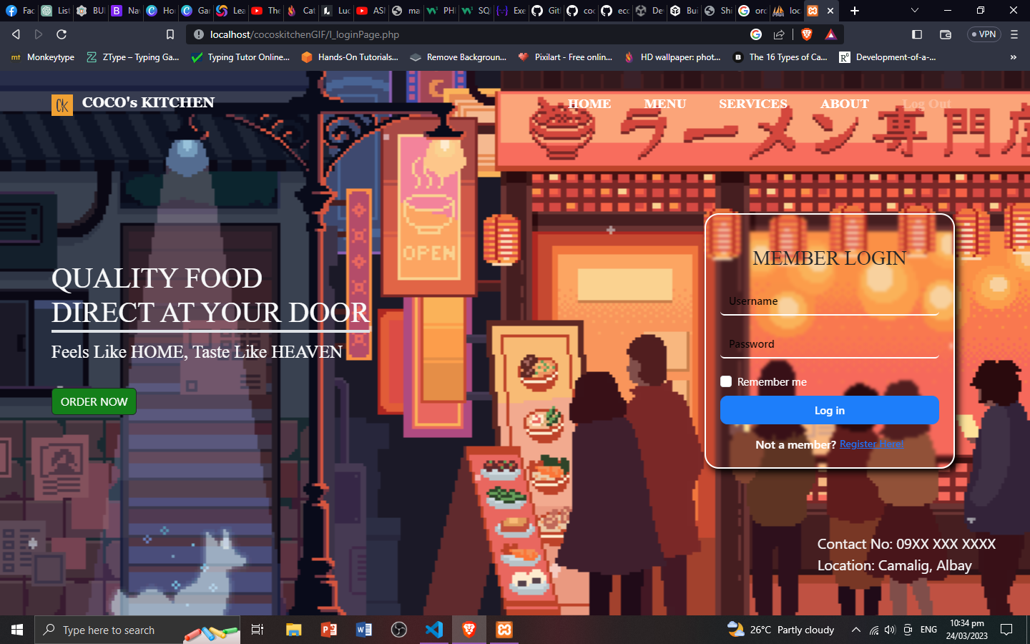

**Internet Technologies**

**(Coco’s Kitchen)**

**Manuel R. Adol Jr.**

**Van Allen J. Callope**

**Mary France H. Maquiniana**

**Emmanuel B. Payonga**

**Melvin V. Porcalla**

**BSIT-3A**

The Mock-UP Designs

Sorting Out Primary and Secondary Keys

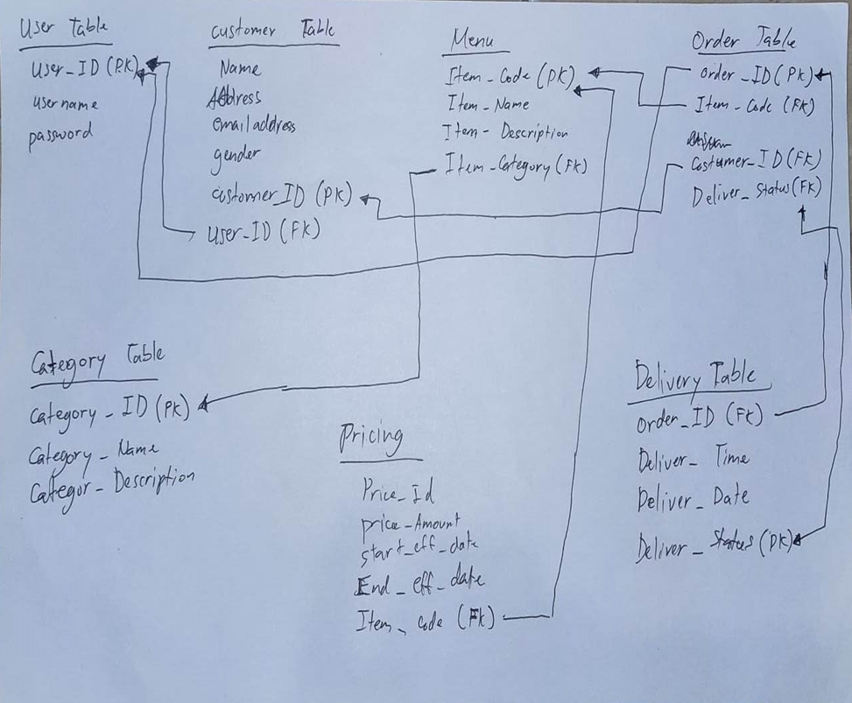

The DFD’s

Level 0

Level 1

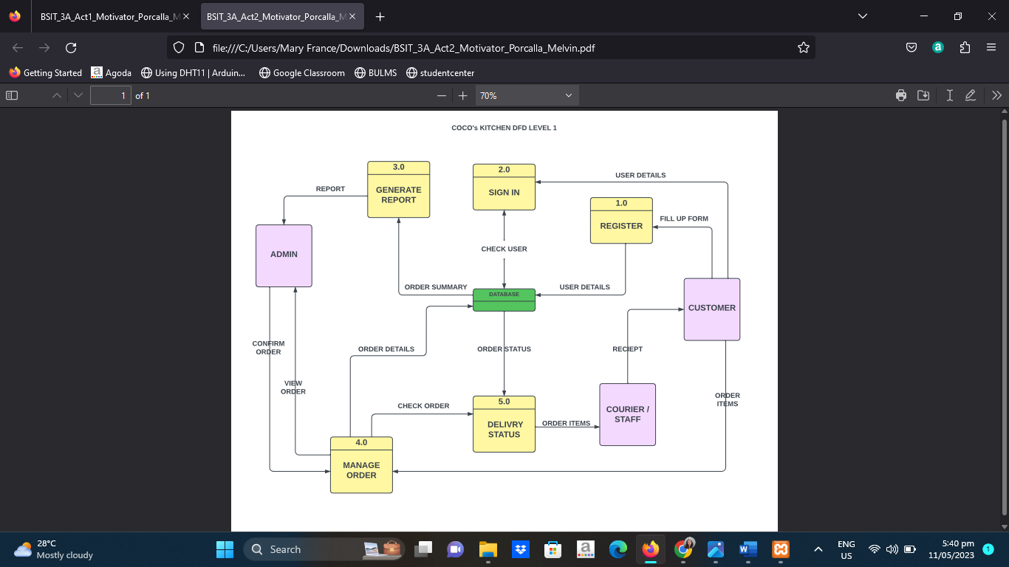

Level 2

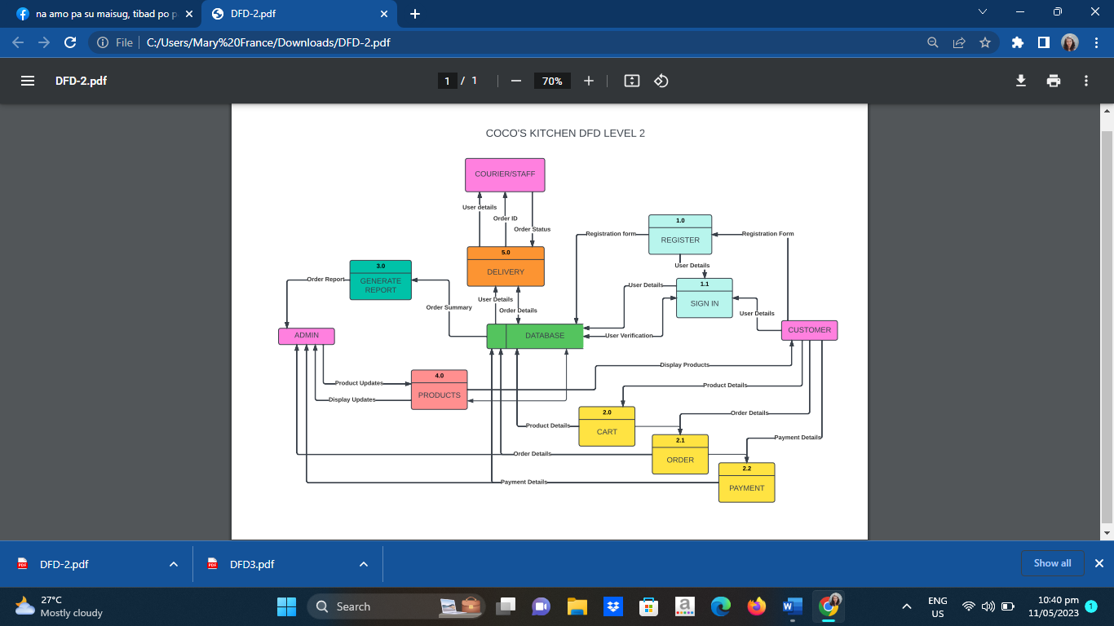Level 3

Sample UI

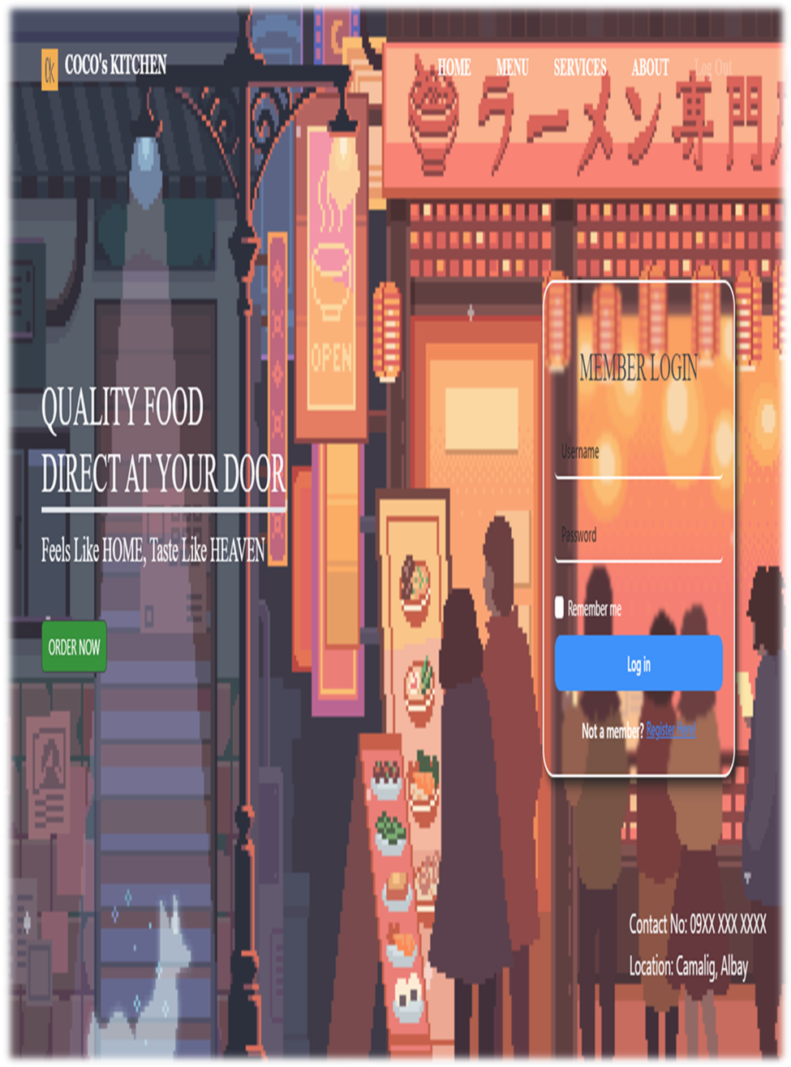

About Coco’s Kitchen

Brief Summary:

Coco's Kitchen is a tapsilogan located at Albay in front of Camalig Bank, Camalig, Philippines. You can contact us at our facebook page at Coco's kitchen. You can also send your emails at coco’skitchen@gmail.com.

Coco's Kitchen offers budget friendly silog meals, short orders, appetizers, soup, sizzling plates, beverages, drinks, set promos, and extras (plain rice, java rice, egg). You can dine in and take out, and we also offer deliveries for online orders. You can visit our website "Coco's kitchen. com" for the transaction of orders. You can easily. choose from our menu, whatever and whenever you want. We are open from 8 am to 8pm. We accept online orders from 8 am to 7pm for the allowance of deliveries. Send us your orders, your location and made of payment (Cash on delivery, G-cash).

We offer quality food that would surely satisfy your palates and will make you order again. and again.

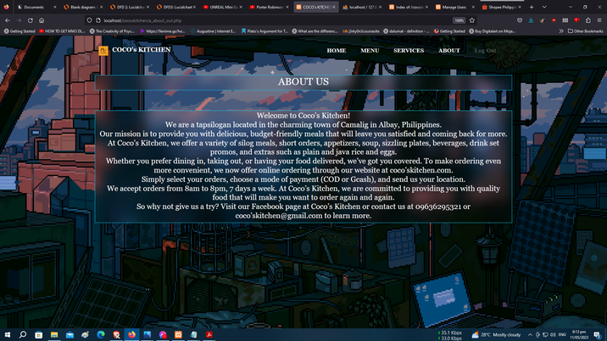

Our Services and Policies

Services:

We will focus on the online services since we know that visiting the store physically only requires us to order, dine in/take out, and pay. For our online services, we provide you our website in which the user/customer is required to make an account. This way, the transaction is clear and has less chances of lost transactions. By having an account, it is easy to use our website. Just click on the menus, choose your orders, send us the location and mode of payment. It is easy, safe, and user friendly.

Policies:

For our policies, we make sure that the rights of the customers are given and respected, with due respect also to our own, that in result, we have a harmonious relationship with our customers. With these said, our policies are to be followed, as we also serve you with our best.

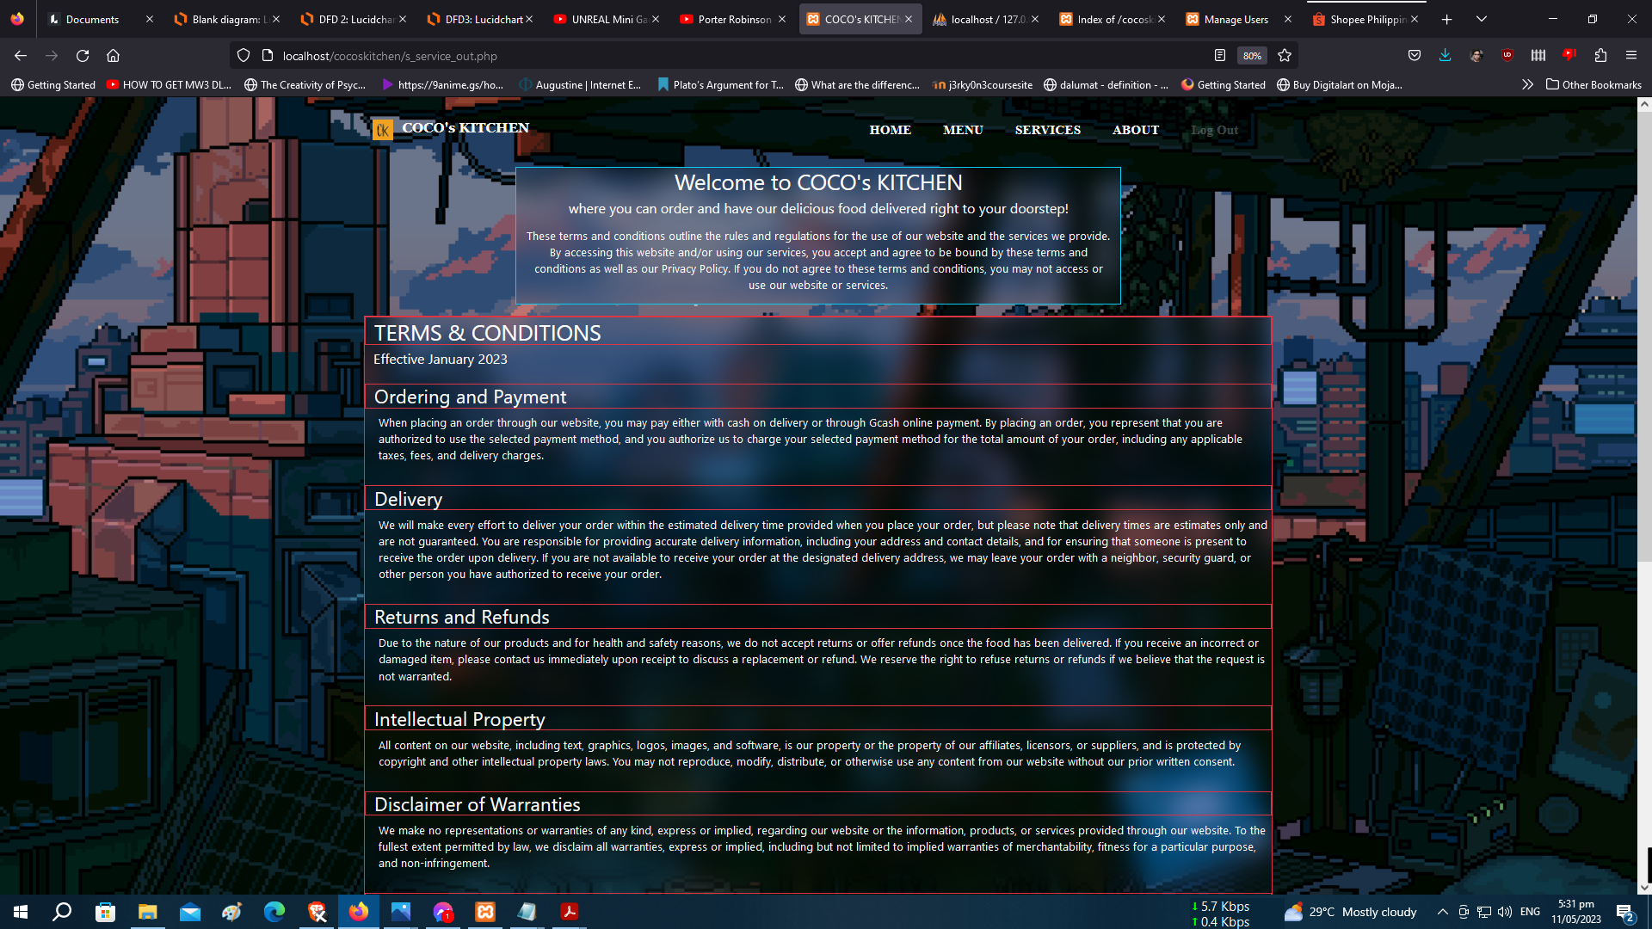

The Database Dictionary

Database Dictionary

|  |  |  |
| --- | --- | --- |
| Coco’s Kitchen | Key/Data type | Description |
| *Category  cat_id  cat_id :int(11)  cat_desc : varchar(20)  cat_status : varchar(1) | Primary key  int  Varchar  Varchar | Category groups the data into a specific type for specific location and access. |
| *Products  item_id  cat_id  item_id :int(11)  item_name : varchar(50)  item_price : decimal(10.2)  item_desc:text  item_file :varchar(256)  item_status :char(1)  date_added : timestamp  item_category : varchar | Primary key  Primary key  Int  Varchar  Decimal  Text  Varchar  Char  Timestamp  varchar | It contains all the products information, filtered, for easy location and avoids mixing of data. |
| *Orders  order_id  user_id  order_id : int(11)  user_id : int(11)  item_id : int(11)  item_name : varchar  item_desc : text  item_qty :int (11)  date_ordered : date  order_status : char(1)  item_file : varchar(255)  item_status : char(1)  date_delivered : timestamp  courier_user_id : int  stock_id : varchar  order_ref_number :varchar | Primary key  Primary key  Int  Int  Int  Varchar  text  Int  Date  Char  Varchar  Char  Timestamp  Int  Varchar  varchar | Displays the order information for saving, locating, and processing of orders for delivery. |
| *Users  User_id  user_id : int(20)  firstname : varchar(30)  lastname : varchar(30)  address : varchar(30)  contact_number : varchar(12)  email : varchar(50)  username : Varchar(50)  password : varchar(50)  user_status : varchar(1)  user_type : varchar  last_update : timestamp | Primary key  Int  Varchar  Varchar  Varchar  Varchar  Varchar  Varchar  Date  Varchar  Varchar  timestamp | Contains the users’ information for the ordering of products, membership, and transactions. |

|  |
| --- |
| Orders |
| *Orders  order_id pk  user_id  order_id : int(11)  user_id : int(11)  item_id : int(11)  item_name : varchar  item_desc : text  item_qty :int (11)  date_ordered : date  order_status : char(1)  item_file : varchar(255)  item_status : char(1)  date_delivered : timestamp  courier_user_id : int  order_ref_number : varchar  stock_id : varchar |

|  |
| --- |
| Products |
| *Products  item_id pk  cat_id  item_id :int(11)  item_name : varchar(50)  item_price : decimal(10.2)  item_desc:text  item_file :varchar(256)  item_status :char(1)  date_added : timestamp  item_code : varchar  item_category : varchar |

|  |
| --- |
| Category |
| *Category  cat_id :int(11) pk  cat_desc : varchar(20)  cat_status : varchar(1) |

|  |
| --- |
| Users |
| *Users  user_id : int(20) pk  firstname : varchar(30)  lastname : varchar(30)  address : varchar(100)  contact_number : varchar(12)  email : varchar(50)  username : Varchar(50)  password : varchar(50)  user_status : varchar(1)  user_type : varchar(1)  last_update : timestamp |